Goitse Mongale
Mpumalanga department of education
IT PAT 2025

Contents Table
Contents
Contents Table 1
Scenario and Scope 2
User Requirements 3
Navigation / Flow Diagram 4
Data Structures 5
Database 5
Relationship between tables 6
Text Files 8
Classes and objects 9
Array 10
Graphical User Interface 11
IPO 14
Screen 1: Sign Up 14
IPO 16
Screen 2: Dispatcher 16
IPO 18
Screen 3: Admin 18

Scenario and Scope

Topic: An application that manages vehicles, routes and shipments. It supports three roles: Admin, dispatcher and driver, each with specific permissions. The system will store data in a small relational database and use arrays, SQL, OOP, and text files.

Description of problem/Task: Efficient transportation is essential for delivering goods on time, ensuring user safety, and keeping costs low. In small to medium-sized companies, tracking vehicle assignments, shipments and delivery status is often done manually, leading to:
- Lost or delayed shipment details
- Confusion about vehicle availability
- Poor communication between dispatchers and drivers
- Inaccurate delivery records

Description of solution: The mini transport management system will centralize vehicle, shipment and user-role data into a small, easy to use application.
- Admins manage system records (vehicles) and generate shipment reports.
- Dispatchers create shipment, assign them to vehicles and drivers, and schedule deliveries.
- Drivers view their assigned shipments and update delivery status.

The system will ensure:
- Each user sees only relevant functions based on their role.
- All data is stored in a database for easy access and updates.
- Reports can be exported to text files for record keeping.
- Temporary arrays are used for batch shipment creation before committing to the database.

User Requirements

 | User 1: Admin | User 2: Dispatcher | User 3: Driver
Role | System  Manager | Shipment Coordinator | Transport Operator
Activity | - Manage system records  - Search and filter vehicles  - View and generate reports on shipments  - Export reports to a text file  - Filter shipments by date | - Create and manage shipment batches  - Assign vehicles and drivers to shipments  - Delete shipments if needed  - Commit temporary drafts to database  - Update shipment status (In Transit, Delivered etc.)  - Search for shipments by ID or status | - Log in to view assigned shipments  - See allocated route, vehicle and status  - Update status when shipment is delivered  - Basic dashboard for tasks
Limitations | - Cannot create or dispatch shipments directly  - Limited to reporting, analysis and system management | - Must validate vehicle capacity before assigning  - Cannot modify users or vehicles directly, they can only assign  - Draft shipments are temporary and can be lost if not committed | - Can’t access admin or dispatcher features  - Limited to viewing own assignments  - No control over user management, vehicles or batch processing

Navigation / Flow Diagram

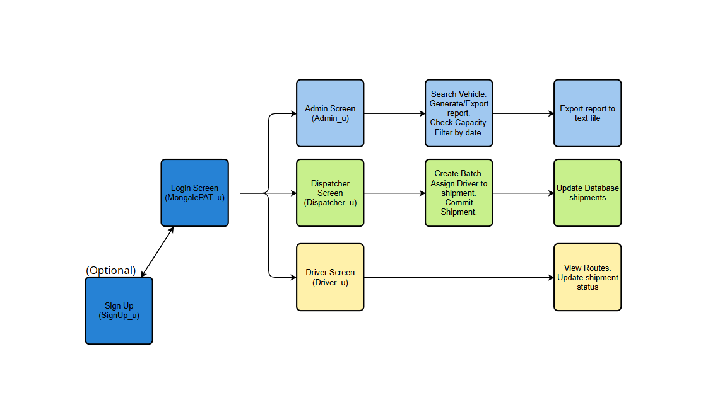

Data Structures

Database

My database is he central storage of all the project’s data (users, vehicles, drivers, and shipments).
It ensures that all my data is organized, consistent, and easily accessible for my program.

Table Name: Vehicles
Key | Field Name | Data Type | Field Size | Example
PK | VehicleID | AutoNumber | Long Integer | 4
- | RegNo | Short Text | 255 | JKL 231 MP
- | CapacityKG | Number (Integer) | Long Integer | 4000
- | Type | Short Text | 255 | Truck

Table Name: Routes
Key | Field Name | Data Type | Field Size | Example
PK | RouteID | AutoNumber | Long Integer | 1
- | StartLocation | Short Text | 255 | Stellenbosch
- | EndLocation | Short Text | 255 | Mosselbaai
- | Distance | Number (Integer) | Long Integer | 60

Table Name: Shipments
Key | Field Name | Data Type | Field Size | Example
PK | ShipmentID | AutoNumber | Long Integer | 2
- | ClientName | Short Text | 255 | Makro
FK -> Vehicles.VehicleID | VehicleID | Number (Integer) | Long Integer | 3
FK -> Users.UserID | DriverID | Number (Integer) | Long Integer | 4
- | Origin | Short Text | 255 | Pretoria
- | Destination | Short Text | 255 | Bloemfontein
- | CreatedAt | Date/Time | - | 2025/08/24

Table Name: Users
Key | Field Name | Data Type | Field Size | Example
PK | UserID | AutoNumber | Long Integer | 2
(Unique) | Username | Text | 255 | Admin1
- | Password | Text | 255 | Admin321
- | Role | Text | 255 | Admin / Dispatcher / Driver

Relationship between tables

Users -> Drivers
- One-to-One / Optional (A user with role = Driver is linked to a Driver record).
- Users.UserID = login credentials, may map to Drivers.DriverID for operational data.
Drivers -> Shipments
- One-to-Many (One driver can handle many shipments).
- Drivers.DriverID is PK, linked to Shipments.DriverID (FK).
Vehicles -> Shipments
- One-to-Many (One vehicle can transport many shipments).
- Vehicles.VehicleID is PK, linked to Shipments.VehicleID (FK).
Users (Admin/Dispatcher) -> Shipments
- Indirect relationship through system roles (Admin manages reports, Dispatcher creates shipments).

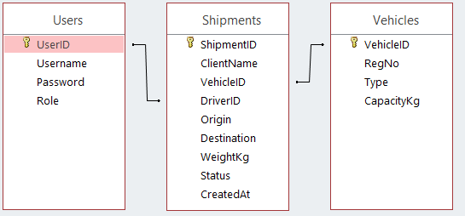

Text Files

My text file acts as an external storage or reporting tool used by admins to export a generated shipment report.

Example of text file:

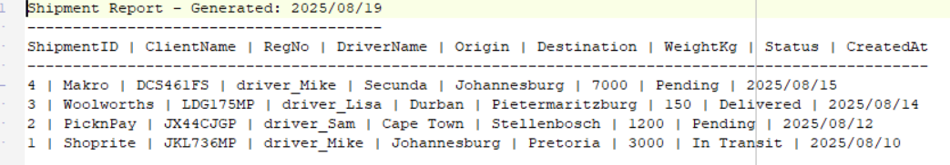

Classes and objects

The class is used to manage one shipment object at a time (methods for updating/assigning).

Class Name: TShipment
Attributes:
- fShipmentID : Integer
Methods
+ Constructor Create(iShipmentID : integer);
Creates a new TShipment object in memory.
iShipmentID is passed in as a parameter.
Inside the constructor, that value is assigned to fShipmentID.

+ function UpdateStatus(sNewStatus:string):Boolean;
Updates the shipment’s status (e.g. "Pending" -> "In Transit" -> "Delivered"). Returns True if the status was successfully changed, otherwise False.

+ function AssignVehicleAndDriver(iVehicleID, iDriverID : integer):Boolean;
Links a vehicle and driver to a shipment.
It takes two integers:
- iVehicleID (FK → Vehicles.VehicleID)
- iDriverID (FK → Users.UserID)

Updates the shipment record so the correct driver and vehicle are assigned.
Returns True if assignment succeeds, False otherwise.

+ property ShipmentID : Integer read FShipmentID;
Allows outside code to read the shipment’s ID, but not change it.
read fShipmentID means the value comes directly from the private field.

- = private
+ = public

Array

My array is used to temporarily store multiple records of various shipments batches before they are permanently committed to Shipments in the Database
Example of array data: arrFDrafts
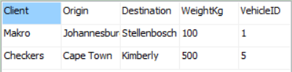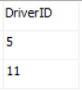

Graphical User Interface

Screen 1: Log in
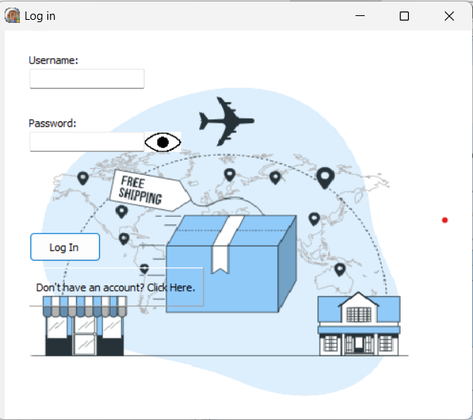

Screen 2: Admin
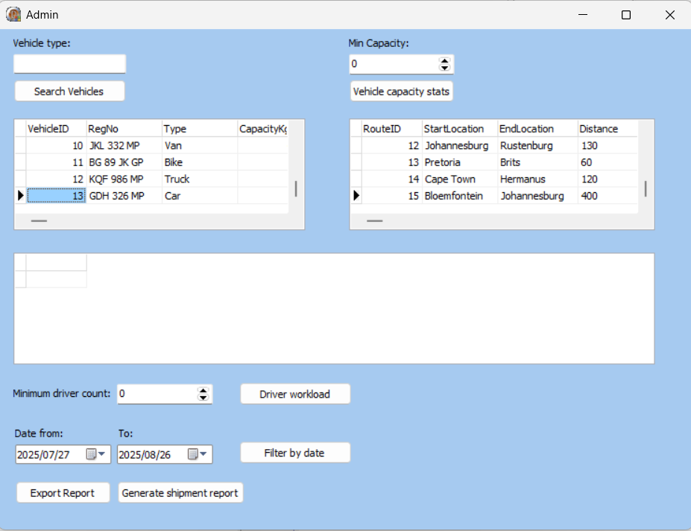

Screen 3: Dispatcher
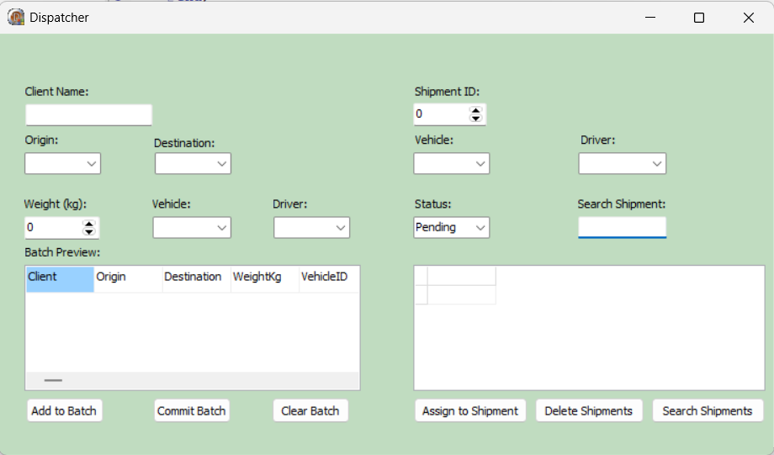

Screen 4: Driver
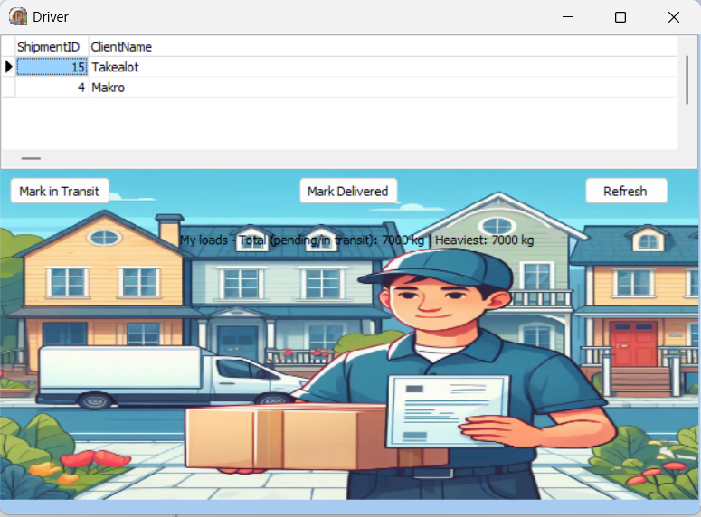

IPO

Screen 1: Sign Up

INPUT
Input | Source | Data Type | Format | GUI Component | Validation
sUsername | Keyboard | String | General text | edtUsername | Must not be empty, must be unique in tblUsers  Error Message:  Username already exists, choose another one.
sPassword | Keyboard | String | General text | edtPassword | Password cannot be empty  Error Message:  Enter a password.
sConfirm | Keyboard | String | General text | edtConfirm | Must match sPassword  Error Message:  Passwords do not match.

PROCESSING
What processing needs to be done | How processing will be done
Validate Username uniqueness | Check if tblUsers[‘Username’] = sUsername already exists  end;
Confirm Passwords match | if sPassword <> sConfirm then  begin  ShowMessage('Passwords do not match.');  Exit;
Save new user | Insert new user into tblUsers

OUTPUT
DATA | Format | GUI Component
Sign-up Confirmation | Signup was successful. | ShowMessage
Error message if problems occured | You can now login.  Failed to create account. Please try again later. | ShowMessage

IPO

Screen 2: Dispatcher

INPUT
Input | Source | Data Type | Format | GUI Component | Validation
cbOrigin.Items | dmRoutes.tblRoutes  ['StartLocation'] | String | General text/  Predefined  Set of Data  From DB | cbOrigin | Must select an Origin.  Error Message:  Select VehicleID and DriverID.
cbDestination.Items | dmRoutes.tblRoutes  ['EndLocation'] | String | General text/  Predefined  Set of Data  From DB | cbDestination | Must select a destination.  Error Message:  Select VehicleID and DriverID.
iCapacityKG | dmRoutes.tblVehicles  ['CapacityKg'] | Integer | Numerical value from DB | dmRoutes.tblVehicles  ['CapacityKg'] | Where tblVehicles VehicleID = iSelectedVehicleID  Error Message: Selected vehicle not found.

PROCESSING
What processing needs to be done | How processing will be done
Validate that Client Name is not empty | if Trim(edtClientName.Text) = '' then  begin  ShowMessage('Enter Client Name.');  Exit;  end;
Ensure Origin and Destination are selected | if (cbOrigin.ItemIndex < 0) or (cbDestination.ItemIndex < 0) then  begin  ShowMessage('Select Origin and Destination.');  Exit;  end;
Validate Weight input (≤ 15000) | if sedWeight.Value > 15000 then  begin  ShowMessage('Weight has exceeded limit.');  sedWeight.Value := 15000;  Exit;  end;

OUTPUT
DATA | Format | GUI Component
edtClientName.Text, cbOrigin.Items[cbOrigin.ItemIndex], cbDestination.Items,  [cbDestination.ItemIndex],  sedWeight.Value, cbVehicleID.Items[cbVehicleID.ItemIndex],  cbDriverID.Items[cbDriverID.ItemIndex] | ClientName, Origin, Destination, WeightKg, VehicleID, DriverID | sgBatch

IPO

Screen 3: Admin

Input | Source | Data Type | Format | GUI Component | Validation
dtFrom.Date | Mouse | TDate | Date/time | dtFrom | Sets a default date of 30 days prior to the current date
iMinCap | Keyboard/Mouce | Integer | Numerical value | sedMinCapacity | Cannot be a negative value

PROCESSING
What processing needs to be done | How processing will be done
Generate report | Search through tblShipments and store specific data in qryResult.SQL.Text.
Export report | Write the value generated to Shipments.txt

OUTPUT
DATA | Format | GUI Component
Report of shipment | (exported to a .txt)  Headline <tab>  ShipmentID <tab> ClientName <tab> VehicleID <tab> DriverID <tab> Origin <tab> Destination <tab> WeightKg <tab> Status <tab> CreatedAt | TextFile

